**CP Club 365 Days Challenge**

**Programming language – C++**

**Problem Statement**

<https://www.codechef.com/problems/PRPOTION>

Git :- <https://github.com/Vedantbharad2603/CP_club_365_Days>

**Your Code**:

// 0x104Day of 0x365Days challenge

// VEDANT BHARAD

// 29-1-2023

#include <iostream>

using namespace std;

int grater(int a,int b)

{

    if(a>b) return a;

    return b;

}

int maxnum(int a,int b,int c)

{

    return max(max(a, b),c);

}

int main() {

    // your code goes here

    int t;

    cin >> t;

    while(t--) {

        int R, G, B, M;

        cin >> R >> G >> B >> M;

        long long r = 0, g = 0, b = 0, temp;

        for(int loop = 0; loop < R; loop++) {

            cin >> temp;

            r = grater(r,temp);

        }

        for(int loop = 0; loop < G; loop++) {

            cin >> temp;

            g = grater(g,temp);

        }

        for(int loop = 0; loop < B; loop++) {

            cin >> temp;

            b = grater(b,temp);

        }

        while(M--) {

            if(r > g && r > b)

                r /= 2;

            else if(g > b)

                g /= 2;

            else

                b /= 2;

        }

        cout<<maxnum(r,g,b)<<endl;

    }

    return 0;

}

**Output (Screen Shot)**:

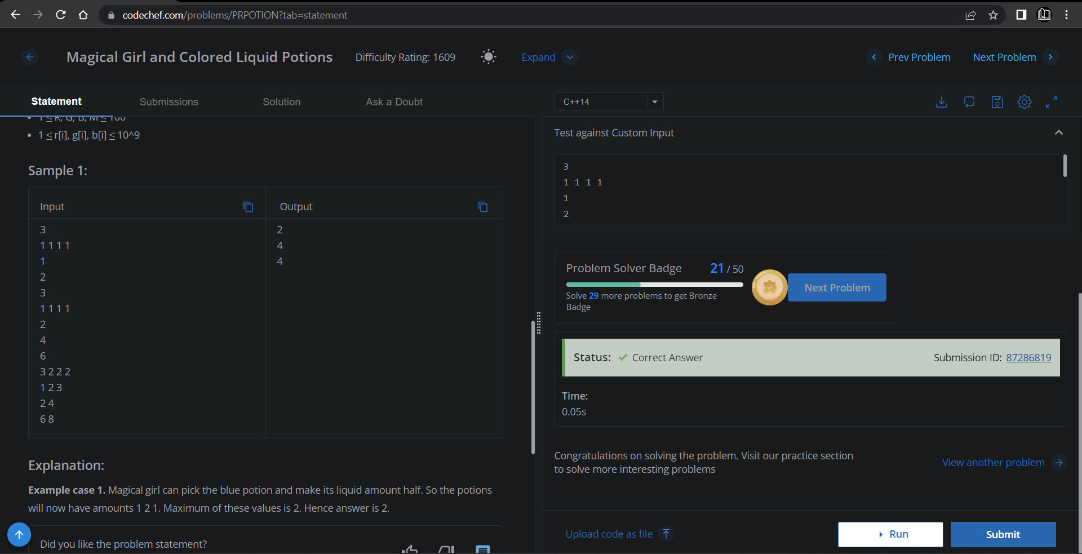

**Understanding about problem:**

* In this task I need to minimize the maximum amount from given three array as given in problem,decrements the amount from the array for m time and then return the maximum number among three.

Note: If you can't understand the problem, feel free to contact us and we'll help you. Please don't copy and paste from anywhere.

ALL THE BEST

Team CP Club